DATABASE SCHEMA

AND

PROCEDURES

DATE:09.12.2023

S.R.TAANUSRI

DATABASE SCHEMA

DEFINITION:

Storage of data in a linear manner.

WHAT IS DB SCHEMA?

* Attributes and instruction for data base engine, how to store the elements and the way the data to be organized.
* The raw data stored is in unstructured form is used ,to retrieve it should be made in a structured manner using database schema.
* It contains :
* Packages
* Primary and foreign key
* View and relationships
* Table and fields
* Schema does not contain any data instead it gathers information about the data and the relationship with the tables.
* Data base object includes
* Formatting data entries
* Unique key for data entries
* Table with multiple columns are specified with name ,data type and data size.
* Size of schema is based on the volume of project data.
* Easily manage and structure data base before coding.

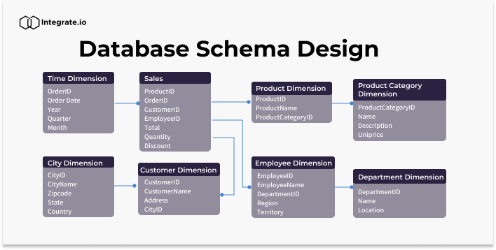

TYPES OF DATABASE SCHEMA

* Logical schema
* Physical schema
* View schema

1.Logical schema

* Specifies logical constraint applied to stored data.
* Integrity constraints are used for defining the set of rules for updating and inserting data into table
* The implementation of the structure cannot be revealed by the people who use database.
* Analyzing database requirements before implementing it in database is called ER modelling.
* ER modelling stands for entity relationships and also specifies relationship between entities.
* Primary key is the unique value in the table it cannot be null or repeated.
* Foreign key relates one table to another table and acts as primary key for other table.
* From the diagram the primary key is no and foreign key is address, no of persons.

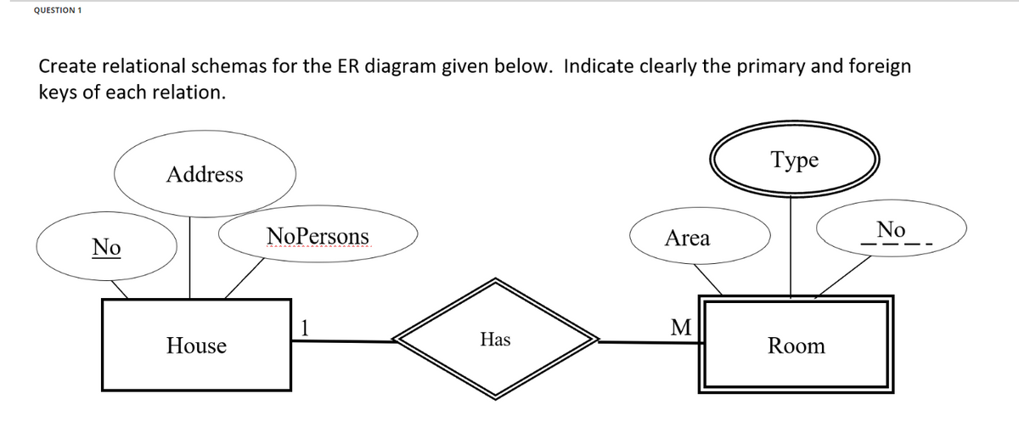

2.Physical schema

* Specifies physically how data is stored in database.
* How the data or information is stored physically in the storage systems in the form of files & indices.

3.View schema

* View level design of database is called view schema.
* Describes end user interaction.

CREATING SCHEMA

1.MY SQL

* CREATE SCHEMA is used to creates the database
* Schema means similar to database

2.ORACLE

* Schema is already present with the database user.
* CREATE SCHEMA helps to view all transactions and object for table.

3.SQL SERVER

* CREATE SCHEMA with name provided by user.

DATABASE SCHEMA DESIGNS

1.FLAT MODEL

* Data is kept in same plane.
* Type of 2-D array contains same type of data and elements
* Contains simple data

2.HIERACHIAL MODEL

* Tree like structure
* Tree structure contain child and root node.
* One-to-many relationship contain parent and child node.
* Suitable for storing nested data
* Used for hominoid classification
* Presented in JSON and XML files.

3.NETWORK MODEL

* Represents vertices and node
* Makes Many-to-Many relationship
* Suitable for spatial calculation

4.RELATIONAL MODEL

* Used for relational database.
* Stores relations of table
* Relational operators are used to calculate different values.

5.STAR SCHEMA

* Best suitable for storing and analyzing huge amount of data.
* Works on facts and dimensions
* Facts are numerical point of data and dimension is for description of facts.
* Structure RDBMS

6.SNOWFLAKE SCHEMA

* Revamping of star schema
* Here dimensions helps to store the dimension data of the table

PROCEDURE

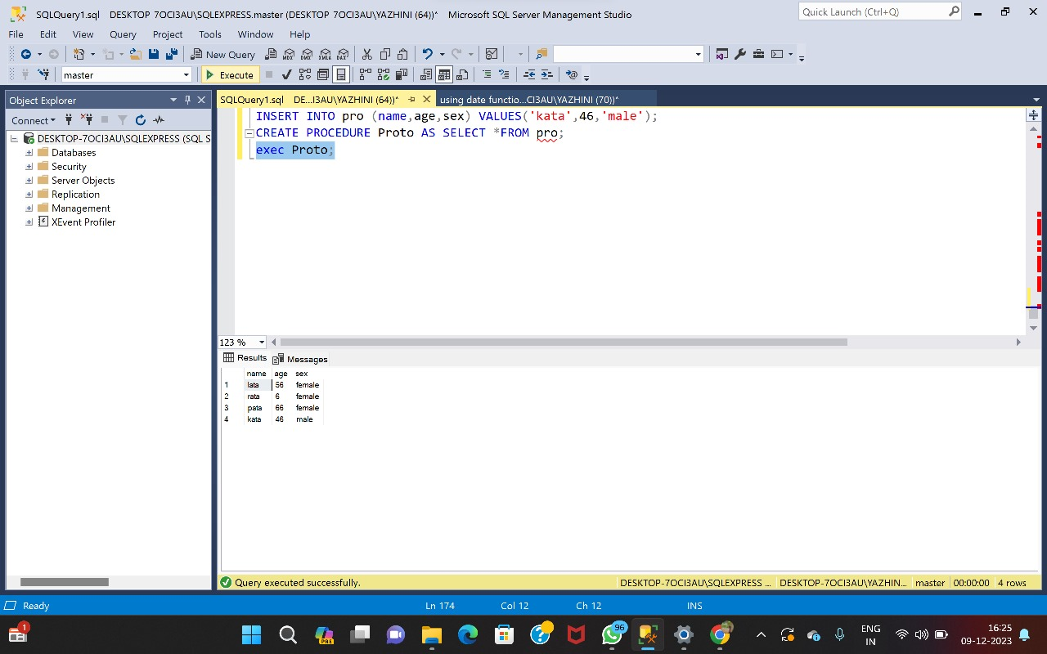

SUBTOTAL

